Electric Wiring Art Project
Physics
You will construct art using your knowledge of circuits. Some materials will be provided and should be returned to your teacher.

A. The Artwork
You may construct your work in any way you like, as long as it meets these criteria:
- use light to enhance the visual imagery
- structural materials can include but are not limited to: canvas, wood, clay, or paper
- artwork must be at least 18 x 24 for 2-D but no larger than 24 x 36 or at least 12 x 18 for 3-D but no larger than 18 x 24
- generate an idea and engage in thoughtful planning to solve a visual art problem

B. Aesthetics
Your artwork should reflect the your perception and:
- be an original in design
- demonstrate an understanding art elements
- use light in an appropriate/expected manner
- express a central theme or idea

C. The Wiring
To earn full credit, each circuit below must be present and working in class:
- There is a switch for each circuit
- One circuit has two lights in series wired correctly with two in parallel
- One circuit has three or more lights in series wired correctly
- One circuit has three or more lights in parallel wired correctly
- One circuit of your choice explained and is wired correctly

Specifics:
- Switches can be made from brads and paper clips.
- Your artwork will be powered by D batteries. You supply your own battery. (The Dollar Tree has batteries for a dollar)
- Each circuit must be able to work independently from the other, but all must be able to be on at the same time without moving the battery.
- All wires must be hidden from view.
- Insulated wire and lights from holiday lights will be provided.
- You will need access to scissors, wire cutters and wire strippers.

D. The Circuit Diagram
You must provide one diagram for the complete circuit in your building. It must:
- be labeled and be complete including all electrical parts for each circuit
- use accurate circuit symbols
- be neat & drawn with a straight edge ruler
- fill an entire piece of 8.5”x11” paper

When your design is submitted it will either be approved or denied. If it is denied, meaning it was not made correctly, you must resubmit your design before construction.
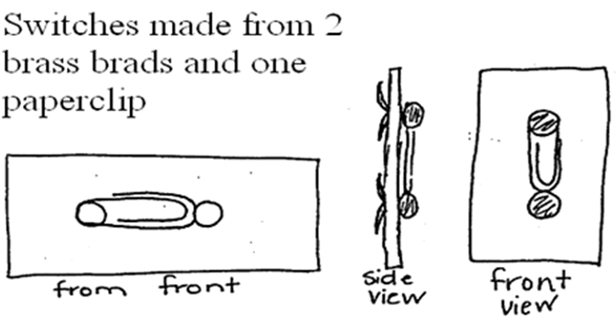
E. Video Submission THIS IS YOUR FINAL GRADE & contingent on the rest of the project
Video: Each video must contain an oral explanation of what is occurring, or an individually labeled video clip of each section of your house to be seen. Each video must contain a continuous run of the entire project from both a science and art perspective. The camera may move to show better effects, but may not be a collection of clips. Note that it is permissible to show a single continuous run of the artwork, and then show detailed clips from different angles of the various sections.

Grading will be based on originality, neatness, and meeting the requirements outlined above. Please title and credit your video, but do not use last names as your videos may be uploaded to Youtube.
Project Checkpoint | Due Date
Artwork Plans with wiring (Circuit Diagram) | Monday, April 20, 2020
Artwork Idea and Basic Outline (no wiring diagrams) | Friday, April 3, 2020
Artwork Complete | Friday, May 8, 2020
Video | Friday, May 15, 2020

Electric Artwork Project Rubric Name: _____________________

1. Approval of Artwork Plans (Without Circuits) Due Friday, April 3, 2020
The artwork plan must clearly show all artwork elements, ideas, and intentions clearly.
(20 pts)
Date submitted: | □ Denied | □ Approved
Resubmitted on: | □ Denied | □ Approved

Approval of Artwork Plans (Circuit Diagram) Due Friday, April 20, 2020
The artwork plan (circuit schematic) must clearly show all inspection elements clearly.
(20 pts)
Date submitted: | □ Denied | □ Approved
Resubmitted on: | □ Denied | □ Approved

2. Artwork Circuitry Inspection: Your artwork will be expected to work as design by this date. I will use the following rubric. Inspection will be Friday, May 8, 2020
Inspection Element | Check | Fine
Series and parallel circuits work independently; Battery doesn’t move |  | -10 pts
There is a switch for each circuit |  | -10 pts
One circuit has two lights in series wired correctly with two in parallel |  | -10 pts
One circuit has three or more lights in series wired correctly |  | -10 pts
One circuit has three or more lights in parallel wired correctly |  | -10 pts
One circuit of your choice explained and is wired correctly |  | -10 pts
The artwork meets minimum but does not exceed maximum size requirements |  | -10 pts

3. Artwork Design Evaluation: In order to determine the design appeal of your artwork, I will use this rubric for evaluation:
Area evaluated: | 13-15 Points | 10-12 Points | 0-9 Point
Blueprint- Design Idea  Due  Friday, April 3, 2020 | The design includes a well identified and detailed vision both conceptually and expressively | The design includes a well identified and detailed vision either conceptually or expressively but not both | The design does not include either a well identified or detailed vision of a concept and is not expressed
Visual Design  Due  Friday, May 8, 2020 | The artwork is a unique pieces with appropriate use of light that expresses the artist vision | The artwork is not unique but uses appropriate lighting to express a vision or the artwork is unique but does not use appropriate light to express the artists vision | The artwork is not unique nor does is express a vision
Visual Appeal  Due  Friday, May 8, 2020 | The artwork is visually appealing with all wires hidden | The artwork is either visually appealing or has hidden wires but not both | The artwork is neither visually appealing nor are the wires hidden.

4. Video Submission: Two videos of the artwork one describing the circuitry in detail and the other describing the visual design and appeal in detail. Due: Friday, May 15, 2020
Area evaluated: | Components | Possible Points | Points Received
Continuous Video | Video showing all components of your artwork with an explanation of the visual appeal and design. | 15
Individual Sections | Video showing individual sections of your artwork explanation of what is happening for each individual circuit. Easy to see. | 30

Artwork Design (without 2.circuit diagram) completed: ______/ 20 points
Artwork Plans (circuit diagram) completed: ______/ 20 points
Artwork Circuitry: ______/ 70 points
Design Evaluation score: ______/ 45 points
Video Submission: ______/ 45 points
Total Value: _____ /200 points

